Assignment 1

Ryan Maguire, id=18464854

23 September, 2019

## Simple exmple

I have created some data and have caculated some numerical and graphical summaries.

Theses are the data:

data1 <- c(10, 23,14,12,34,26,28,24,15)

mean(data1)

## [1] 20.66667

the summary statistics (min, max, Q1, median, and Q3) are:

summary(data1)

## Min. 1st Qu. Median Mean 3rd Qu. Max.   
## 10.00 14.00 23.00 20.67 26.00 34.00

A boxplot would look like

boxplot(data1)

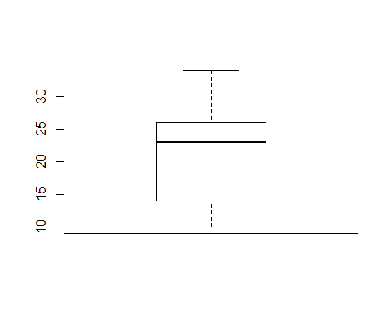 and a histogram ….

hist(data1)

